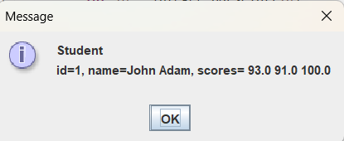

package as09;

//File: Student.java
import javax.swing.JOptionPane;

public class Student implements Status
{
private int id;
private String name;
private double[] scores;

public Student(int id, String n, double[] s)
{
this.id = id;
name = n;
scores = new double[s.length];
System.arraycopy(s, 0, scores, 0, s.length);
}

public int getId()
{
return id;
}

public String getName()
{
return name;
}

public double[] getScores()
{
return scores.clone();
}

public String getStatus()
{
String status = "Student\nid=" + id + ", name=" + name + ", scores= ";
for (int i = 0; i < scores.length; i++) {
status = status + scores[i] + " ";
}
status = status + "\n\n";
return status;
}

public void displayStatus()
{
String status = getStatus();
JOptionPane.showMessageDialog(null, status);
}
}

